Start PIG :

Pig -x local

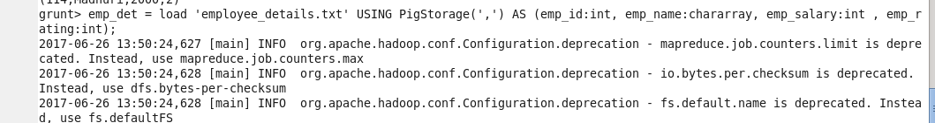

Order Emp Rating , employee.

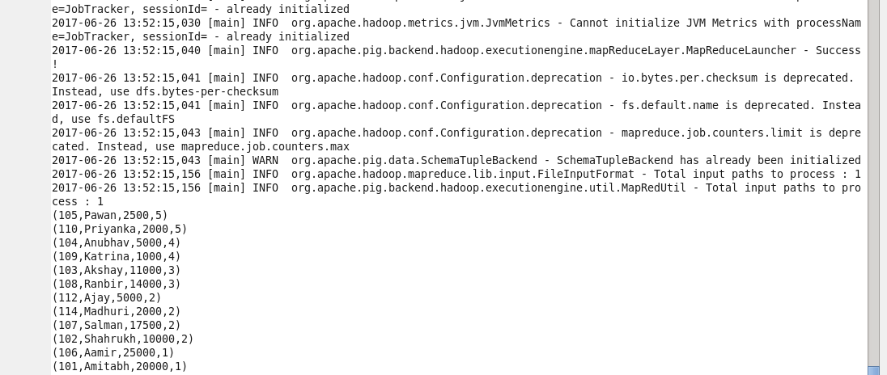

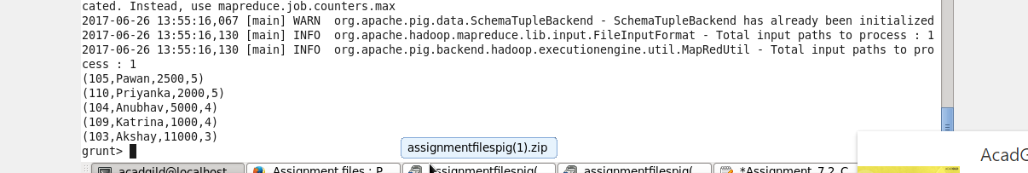

Xform to emp id ,name , rating alone.

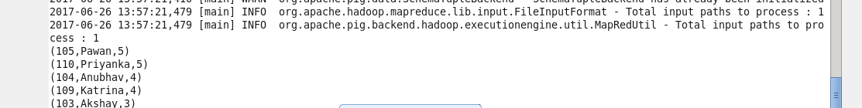

2. Top 3 employee



4. Join ,group

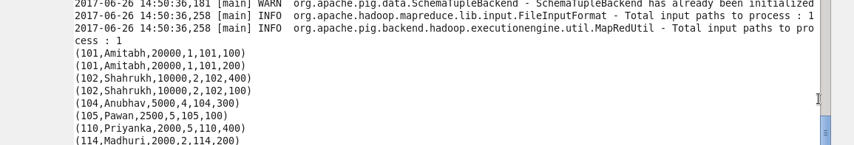

Group by emp_name

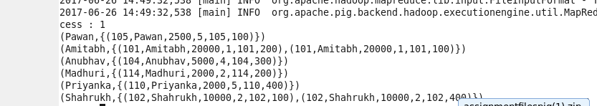

Sum the Employee Expenses and order the record.

**Sum is not working**

**List of employees (employee id and employee name) having no entry in employee_expenses file.**

Outer Join and then filter emp_expenses is null and then foreach generate

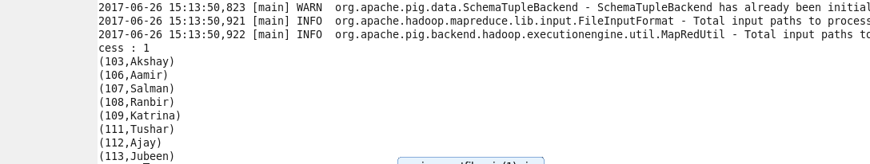

**List of employees (employee id and employee name) having entries in employee_expenses file.**

Outer join and then filter emp_expenses is not null then foreach generate command to filter empnam and emp id and then use distinct.

